CS008

Zach Bernstein, Olivia Hurd, and Maria Kissel

Assignment: Final Project- Bernstein & Co.

Final Project: Bernstein & Co.

Version <1.0>

Table Of Contents

Time Log 3

Introduction 4

Purpose 4

Definitions, acronyms, and abbreviations 4

Overall Description 4

Story Board 5

Specific requirements 6

|  |  |  |  |
| --- | --- | --- | --- |
| Time Log | | | |
| Estimated time to complete assignment => | | | 40 Hours |
| Date | Time Spent  (in hours) | Description | Author |
| 3/29 | .75 | First Version of Software Requirements | Zach, Olivia, Maria |
| 3/30 | .75 | Body content for homepage + images | Maria |
| 4/03 | 2 | Body content for About page + images | Olivia |
| 4/05 | .75 | Group meeting about progress + new task assignments | Zach, Olivia, Maria |
| 4/05 | .75 | Top.php completed | Zach |
| 4/09 | 1.5 | Menu & owner page content | Olivia |
| 4/12 | 1 | Menu & owner page content | Maria |
| 4/13 | 1 | Group meeting – upload progress + new task assignments | Zach, Olivia, Maria |
| 4/21 | 1 | Top, Nav, and Footer | Zach |
| 4/24 | 1 | Location info for each restaurant | Maria, Olivia |
| 4/27 | .75 | Group meeting + upload finished html code + new task assignments | Zach, Olivia, Maria |
| 4/28 | 2 | PHP reservation code | Zach |
| 4/28 | 2 | CSS development | Maria |
| 4/29 | 1 | PHP reservation code | Zach |
| 4/29 | 1.5 | CSS development | Maria |
| 4/30 | 2 | CSS development | Maria |
| 5/2 | 2 | Group Meeting + HTML reservation code | Zach, Olivia, Maria |
| 5/2 | .75 | CSS development | Maria |
| 5/3 | 1.5 | CSS development | Maria |
| 5/3 | 1 | Spec document updating | Olivia |
| 5/4 | 4 | Final group meeting + finishing touches + syncing files + finishing spec document | Zach, Olivia, Maria |
|  | 27 | <=Total Time Spent |  |

# Introduction

### Purpose

The purpose of this document is to describe the requirement specification for the web site “Bernstein & Co”.

The intended audience for this document is anyone who may be

*First it is the contract between you and the client. Second it is for the developer of the site. Two primary goals are:*

1. *Client gets a very good understanding of what you will be delivering.*
2. *Developer has a very good understanding of what they are going to create.*

### Definitions, acronyms, and abbreviations

*Sample for the client:*

ER Diagram – a diagram to represent the data you want to save with your system

W3 Validation – refers to both Html and CSS validation tool provided by the W3c.org. the html validator is located at:

<http://validator.w3.org/>

with the CSS validator located at:

<http://jigsaw.w3.org/css-validator/>

# Overall Description

Our website provides information about a steakhouse we created called Bernstein & Co. We created a back story for this family-run restaurant and developed it as a modern yet classic restaurant serving food made with the highest quality ingredients perfect for celebrating any occasion. Bernstein & Co. has three locations: Boston, MA, Chicago, IL, and Burlington, VT. Each location has a different menu, which can be accessed through our website. A map shows each of the locations, and users can easily find the restaurant’s address, phone number, and hours of operation. Visitors to our website can also make reservations quickly and easily by providing some simple information to help us prepare them for the best experience possible. We ask for the number of people in the party, the restaurant location, the preferred date and time of the reservation, and contact information, as well as additional information to let us know if the group will need any kids’ menus or high chairs.

# Story Board

**Sitemap of Bernstein & Co.**



**CSS/Storyboard**



# Specific requirements

1. *Title for main page*: Bernstein & Co.
2. *Meta Description*: *Bernstein & Co. Steakhouse*
3. *Meta Character set*: UTF - 8
4. *Logo*: **
5. *Main page photo*: 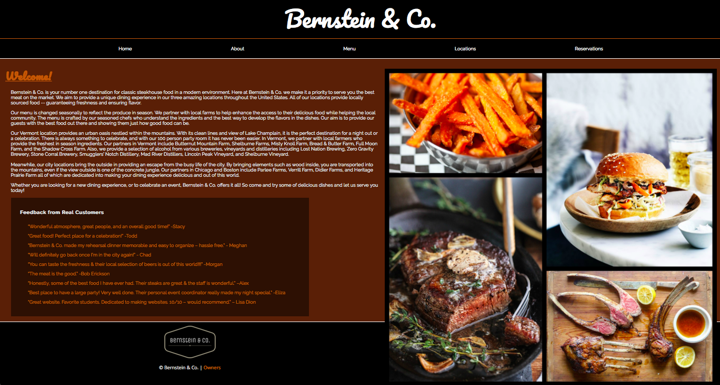
6. *Content can be found here*:
7. I hope you get the idea. The goal would be the developer would be able to make the entire site based on this document and the client would see you have included everything.